Ex No:1 | PASSPORT AUTOMATION SYSTEM

AIM:
To draw the diagram [usecase] for the Passport Automation System.
SOFTWARE USED:
Umbrello
USE CASE DIAGRAM:

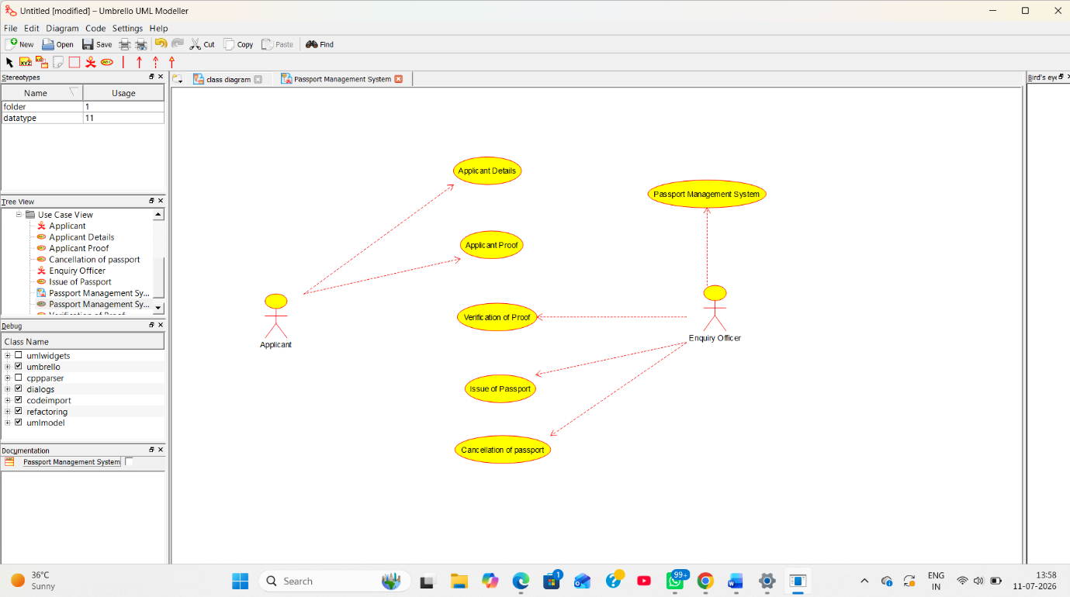

RESULT:
Thus the diagram [use case] for the Passport Automation system has been designed, executed and output is verified.

Ex:No:02 | BOOK BANK REGISTRATION SYSTEM

AIM:
To draw the diagrams [usecase] for the Book bank registration system.
SOFTWARE USED:
Umbrello
USE CASE DIAGRAM:

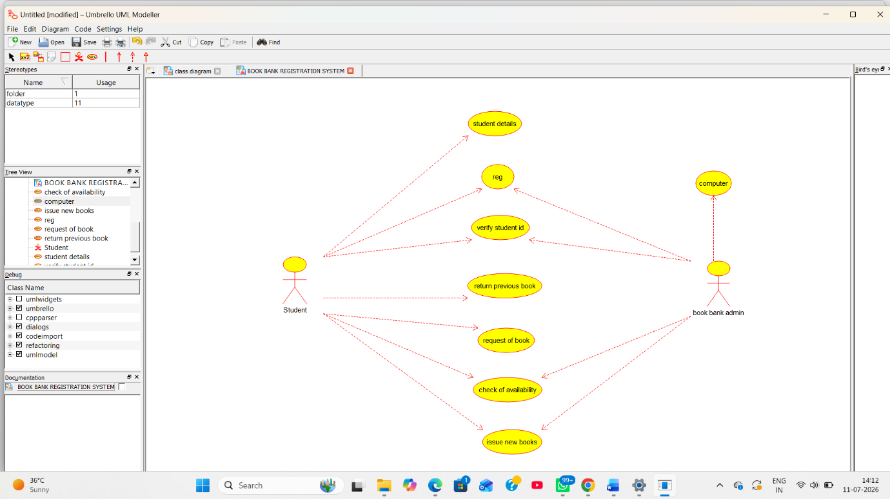

RESULT:
Thus the diagrams [use case] for the Book bank registration system has been designed, executed and output is verified.

EX NO: 3 | EXAM REGISTRATION SYSTEM

AIM:
To draw the diagrams [use case] for the Exam registration system.
SOFTWARE USED:
Umbrello
USE CASE DIAGRAM:

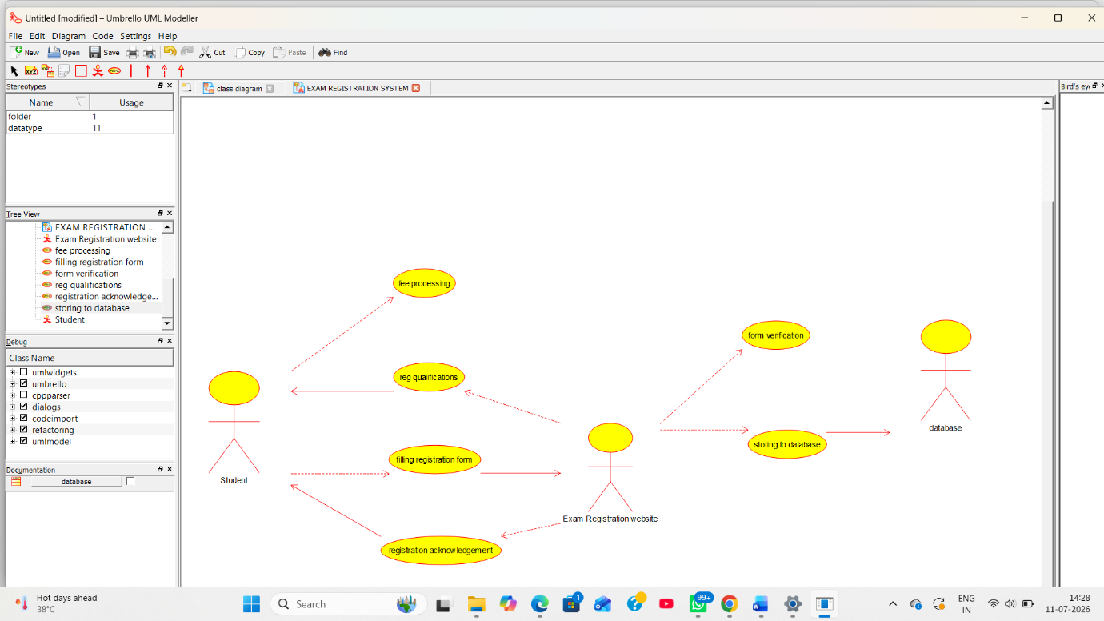

RESULT:
Thus the diagrams [use case] for the Exam registration system.

EX:NO:4 | STOCK MAINTAINANCE SYSTEM

AIM:
To draw the diagrams [ usecase] for the Stock maintainence system.
SOFTWARE USED:
Umbrello
USE CASE DIAGRAM:

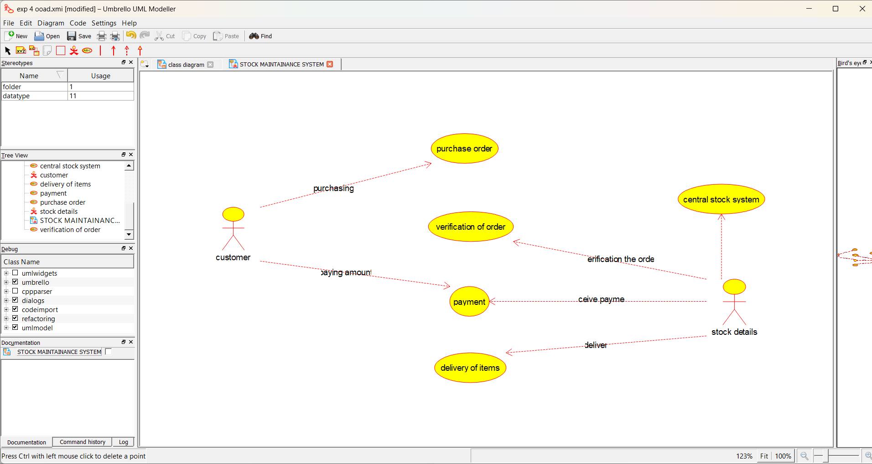

RESULT:
Thus the diagrams [usecase] for the Stock maintainence system.

EX NO:5 | ONLINE COURSE RESERVATION SYSTEM

AIM:
To draw the diagrams [usecase] for the Online course reservation system.
SOFTWARE USED:
Umbrello
USE CASE DIAGRAM:

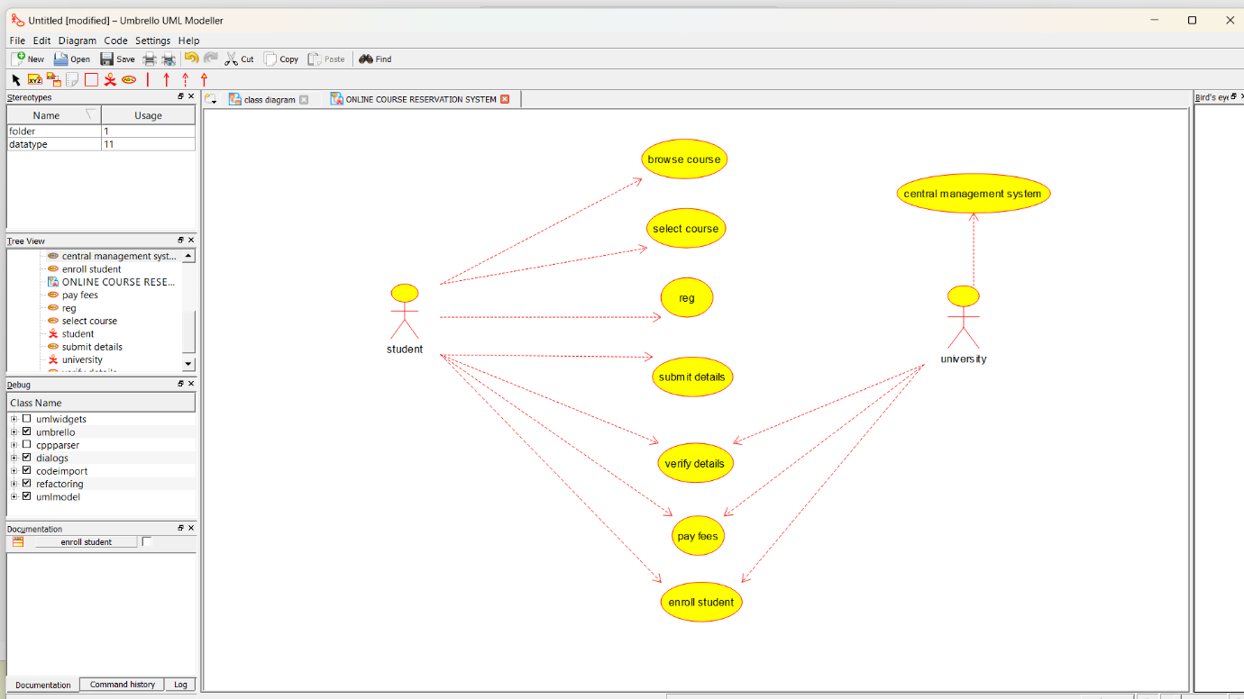

RESULT:
Thus draw the diagrams [usecase] for the Online course reservation system has been designed executed and output is verified.

